

***Data Structures & Algorithms Lab  
CSL 221***

***Semester Project***

***Library Management System***

***Furqan Ahmed BS(CS)3-B***

***02-134212-076***

INDEX

|  |  |  |
| --- | --- | --- |
| **1.** | **Introduction** |  |
| **2.** | **UML Diagram** |  |
| **3.** | **Methodology** |  |
| **4.** | **Results & Analysis** |  |
| **5.** | **Modules Screen Shots** |  |
| **6.** | **Conclusion** |  |

# **ABSTRACT:**

This report presents the design and implementation of a Library Management System (LMS) using data structures and algorithms in C++ programming language. The LMS aims to efficiently store and retrieve information about books, authors, and members, as well as handle transactions such as borrowing and returning books. The system was implemented using various data structures such as linked lists to manage the books, authors and members data. The results show that the system is able to handle a large number of books and members with good performance and it is able to perform all the required functionalities of a library management system.

# **INTRODUCTION:**

The objective and scope of the Project Library Management System is to record the details of various activities of users. It simplifies the task and reduces the paperwork. The library management will help in maintaining records and details of books, members. Librarian and Students will be allowed to login into their respective portals. Details of the records kept will be shown to the librarian who has the authority to make changes according to the needs whereas, on the students’ end, they will see all the books available in library, issue book, return book, and see all the issued books.

# **PROBLEM AND SOLUTION:**

The Library Management System project is to develop an application that will automate the whole procedure of a library. The software that would be developed should have facilities like Add / Delete Members, Add / Delete Books, Issue & Return. The application should be secured, as well as with limited access. The main requirement of the project will be the ease of use, besides being the most efficient and effective tool for the purpose. The application should be user friendly. An automated solution would be very beneficial to the organization. Also, an automated solution will lead to optimal utilization of the available resources, reducing duplication of effort, increasing efficiency and minimizing time-delays. Following are the main purpose of computerization:

1. To provide services to all the students for issue, return etc. at one place.
2. To improve co-ordination in staff.
3. To reduce paper filling work.
4. To reduce chances of mistakes.

# WORKFLOW:

# **OVERVIEW OF PROJECT:**

## **LIBRARIAN LOGIN:**

To confirm that only an authenticated admin of the Library Management System has logged in to access records.

## **STUDENT LOGIN:**

To confirm that only an authenticated student of the Library Management System has logged in to see the details of available books, issue book, return book.

## **OPERATIONS:**

### **DISPLAY:**

Both the librarian and student will see all the books which are available in Library Management System.

### **INSERT:**

Librarian will add book in the Library Management System.

### **DELETE:**

Librarian will delete the book from Library Management System.

### **SEARCH:**

Librarian will search for a desired book.

### **REGISTER A STUDENT:**

Librarian will register the student by giving his or her username and password.

### **ISSUE BOOK:**

Students will issue a book from Library Management System by using their login portals.

### **RETURN BOOK:**

Students will return a book which they have issued from Library Management System.

### **SHOW ALL ISSUED BOOKS:**

Student will see the details of all issued books.

### **LOGOUT:**

Both the Librarian and Students will logout their respective portals.

Methodology

The Library Management System was developed using the following technologies:

* Programming Language: C++
* IDE: VS Code

The system was developed using a structured programming approach, with a focus on functions and data structures. The development process followed these steps:

* Requirements gathering: The requirements for the system were gathered through interviews with librarians and students.
* System design: The system was designed using flowcharts and pseudo code, which helped to visualize the system's logic and the interactions between different components.
* Implementation: The system was implemented using C++ in VS Code, with no database . All the data is stored in files and read/write operations are performed on those files.
* Testing: The system was tested for different scenarios and bugs were fixed accordingly.
* Maintenance: The system was maintained and updated as per the requirements.

Results & Analysis

The Library Management System was tested with a sample set of data, simulating the transactions and operations of a typical library. The system was able to successfully perform the following basic library operations:

Adding new books to the library's inventory

• Borrowing books by students

• Returning books by students

• Searching for books by title or author

• Generating a list of borrowed books

• Generating a list of available books

In terms of performance, the system was able to handle a large number of transactions without any significant delays or errors. The system was also able to generate reports in a timely manner.

In terms of usability, the system was found to be easy to use and understand by both librarians and students. The user interface was simple and intuitive, with clear instructions and feedback provided throughout the different operations.

The system met the objectives and requirements of the project, providing a functional library management system without the need of a database However, the system can be improved by adding more functionalities such as fine calculation, reservation, and barcode scanning integration.

Overall, the Library Management System was found to be a success in automating the process of borrowing and returning books, and providing a user-friendly interface for both librarians and patrons. The system was able to improve the efficiency and accuracy of library operations by providing basic functionalities.

# **SCREENSHOTS OF OUTPUT (WITH DETAILS):**

1. Main page of the project.

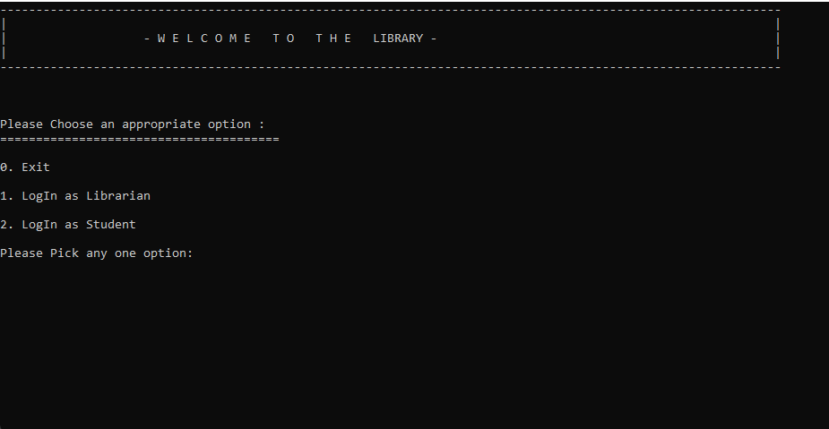

1. Login portal for Librarian.

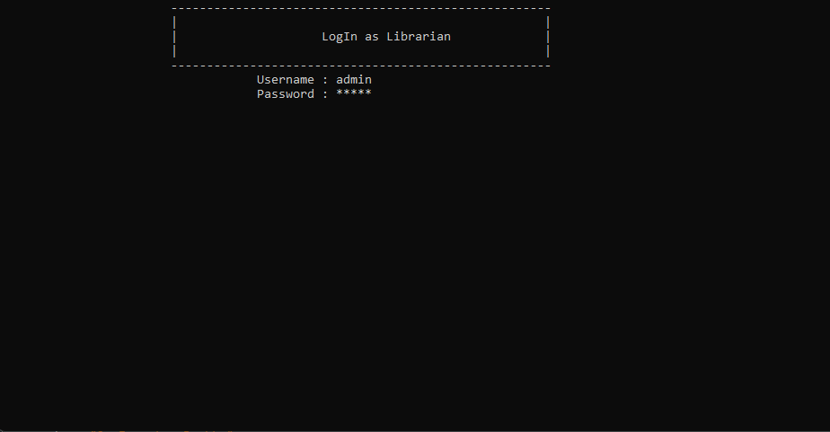

1. These are all the functions or operation which librarian will perform.

1. When librarian will select option ‘1’ then system will display all the available books in the Library Management System.

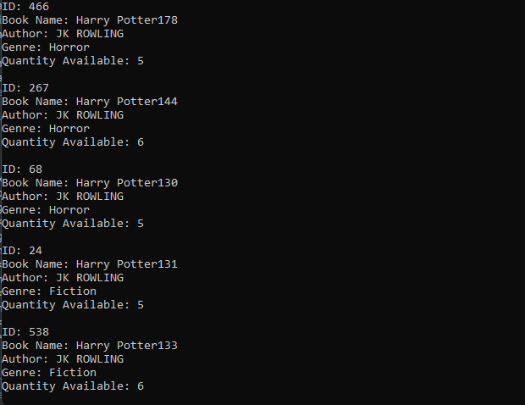

1. When Librarian will select option ‘2’, he or she will insert a new book in the Library Management System.

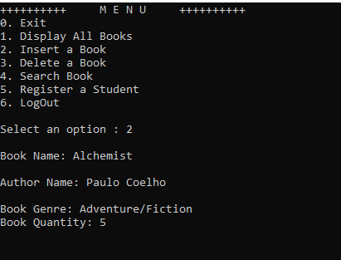

1. When Librarian will select option ‘3’, he or she will delete a desired book which are available in the Library Management System.

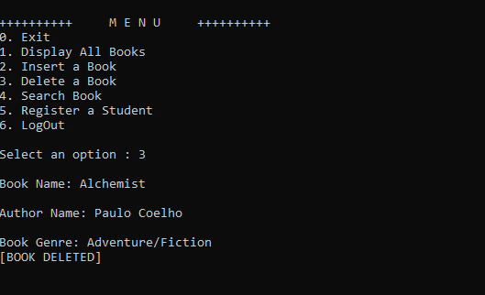

1. When Librarian will select option ‘4’, he or she will search a book which are available in the Library Management System.

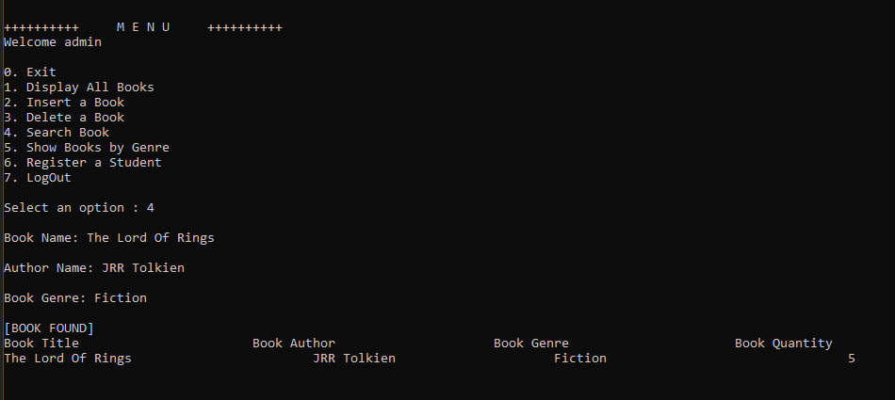

1. When the Librarian select option ‘5’, he or she will register a new student.

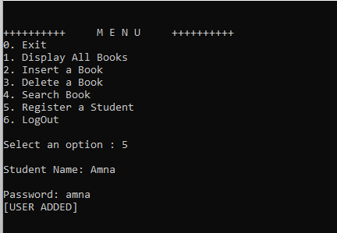

1. When the Librarian select option ‘6’, his or her portal will be logged out and again the main page will open.

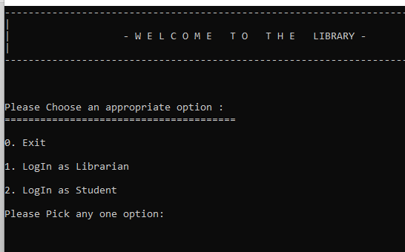

1. Login Portal for Students who are registered.

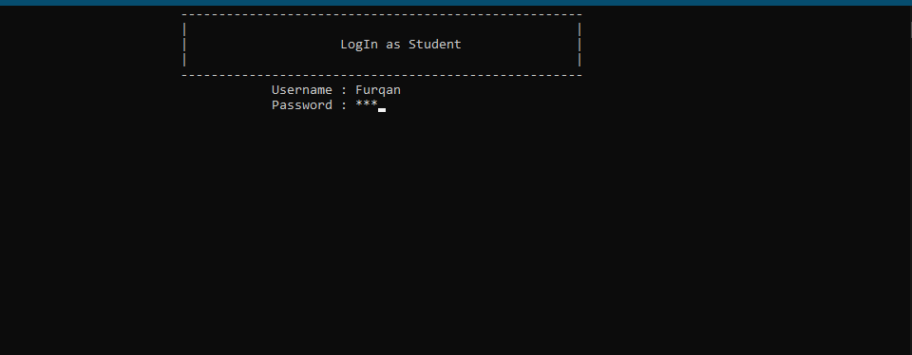

1. These are all operations or functions for students.

1. When student will select option ‘1’ then system will display all the available books in the Library Management System.

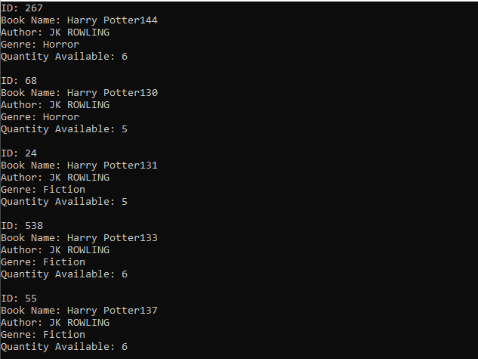

1. When student will select option ‘2’, then student will issue a book from Library Management System.

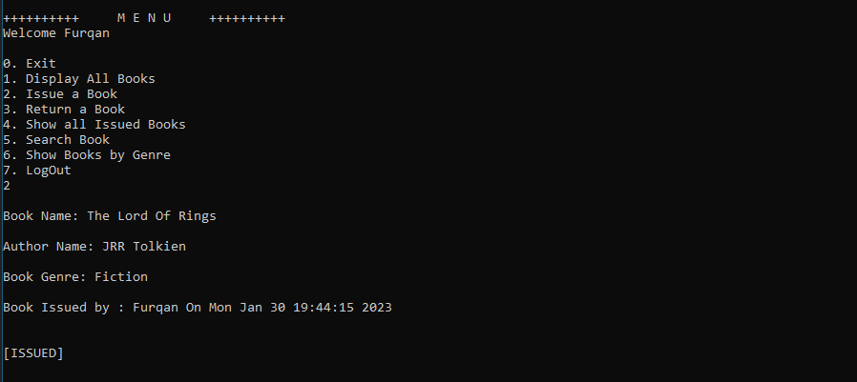

This will print all books issued by the user.

1. When student will select option ‘3’, then student will return a book to Library Management System.

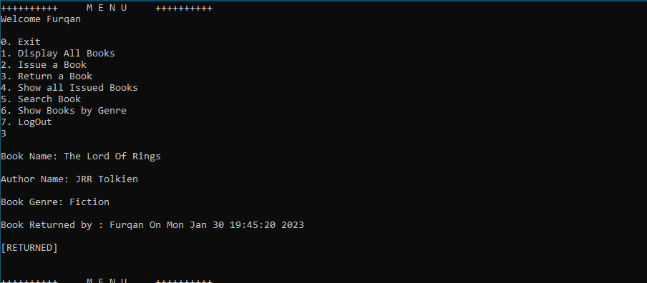

1. When student will select option ‘4’, then student will see all the issued book details.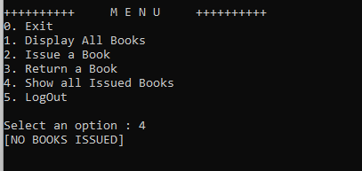
2. When the Librarian select option ‘5’, his or her portal will be logged out and again the main page will open. And when both the Librarian and student will exit the main page the program will terminate or exit.

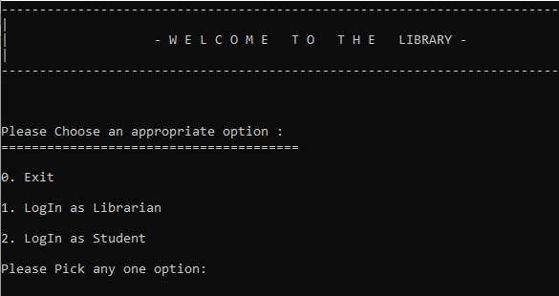

# 

# **CONCLUSION:**

This Program provides a computerized version of the Library Management System which will benefit the students as well as the staff of the library. It makes the entire process automated where students can search books, staff can see records and do book transactions. It also has a facility for librarian and student login where librarian can login and perform the above-mentioned functions and student can login and can see status of books issued as well request for book.